Week 6 - Data Analysis Report

Name : Swayam Rudrawar

Objective:
The objective of this activity was to analyse the recorded light intensity datasets collected from the BH1750 sensor. The raw datasets were cleaned, analysed statistically, smoothed using a moving average filter and checked for anomalies. The results help in understanding sensor behaviour and improving data quality before further processing.

Software Used:
- Python
- Pandas
- NumPy
- Matplotlib
- VS Code

Tasks Performed:
- Imported Bright, Dim and Dark datasets.
- Removed duplicate and missing values.
- Generated cleaned datasets.
- Calculated statistical parameters (mean, median, variance, standard deviation, minimum and maximum).
- Applied Moving Average smoothing.
- Detected anomalies using the IQR method.
- Generated raw plots, smoothed plots, histograms, boxplots and anomaly plots.

Statistical Summary:
Dataset | Mean | Median | Variance | Std Dev | Minimum | Maximum | Range | Total Readings | Removed Anomalies
Bright | 2399.9 | 1788.33 | 4247921.15 | 2061.05 | 0.83 | 8616.67 | 8615.84 | 38144 | 1349
Dim | 76.73 | 79.17 | 1041.93 | 32.28 | 23.33 | 154.17 | 130.84 | 38144 | 1591
Dark | 9.25 | 5.0 | 62.48 | 7.9 | 0.0 | 30.83 | 30.83 | 38144 | 195

Bright Dataset
The bright dataset was analysed by plotting the raw sensor readings, applying a moving average filter, studying the data distribution using a histogram, identifying outliers through a boxplot and highlighting anomalies.
Raw Data
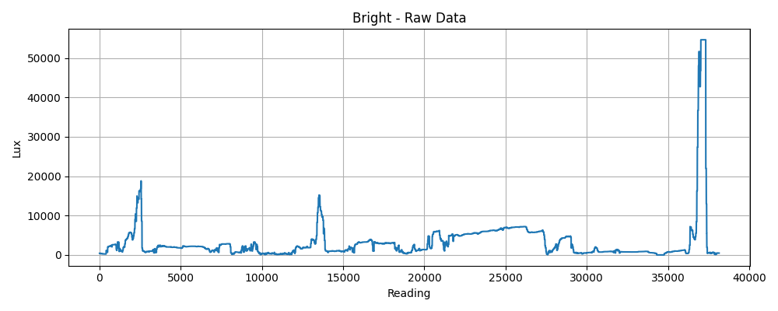
Smoothed Data
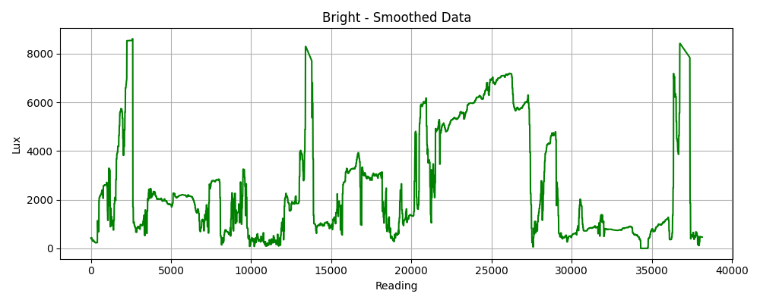
Histogram
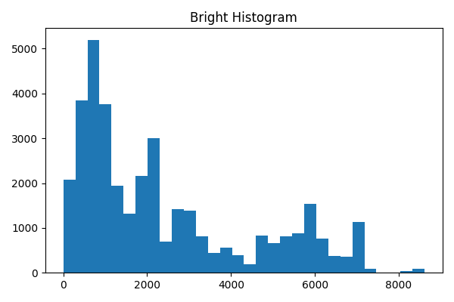
Boxplot
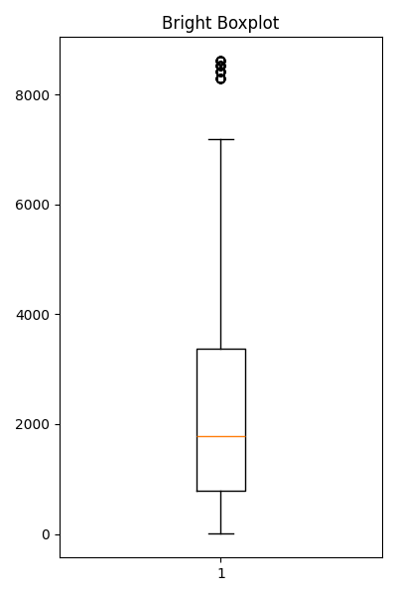
Anomaly Detection
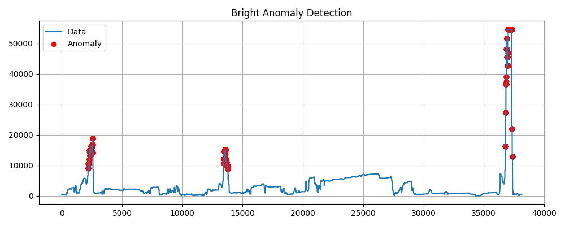

Dim Dataset
The dim dataset was analysed by plotting the raw sensor readings, applying a moving average filter, studying the data distribution using a histogram, identifying outliers through a boxplot and highlighting anomalies.
Raw Data
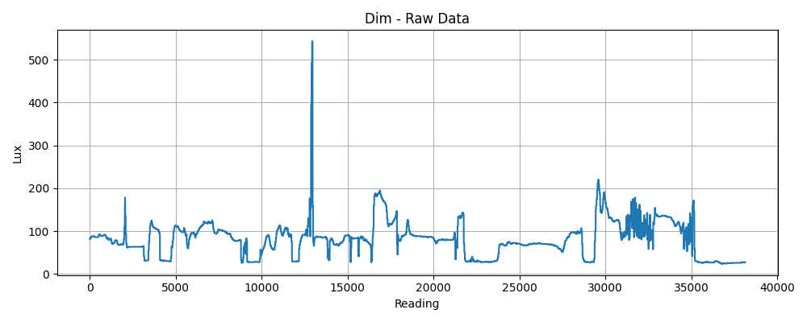
Smoothed Data
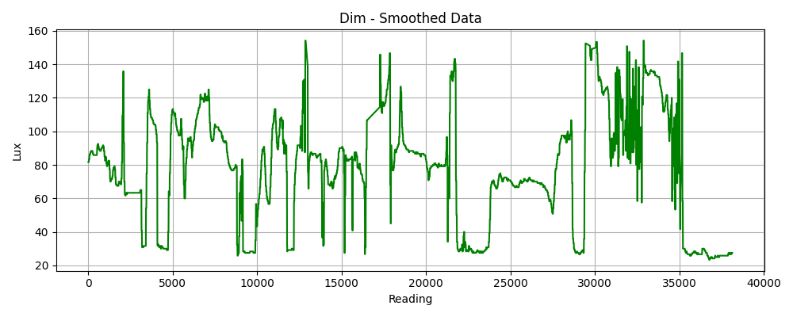
Histogram
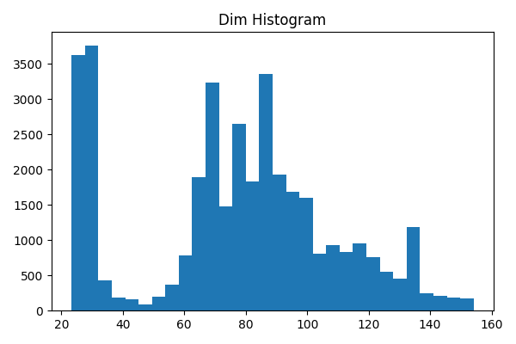
Boxplot
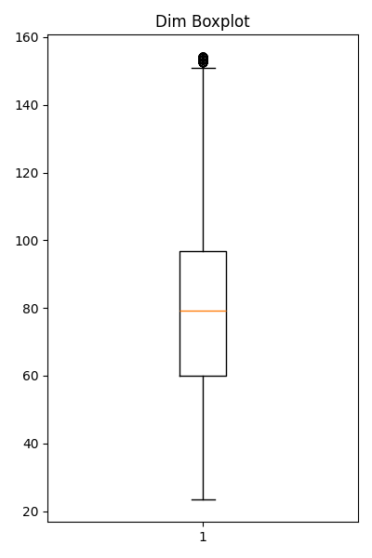

Anomaly Detection
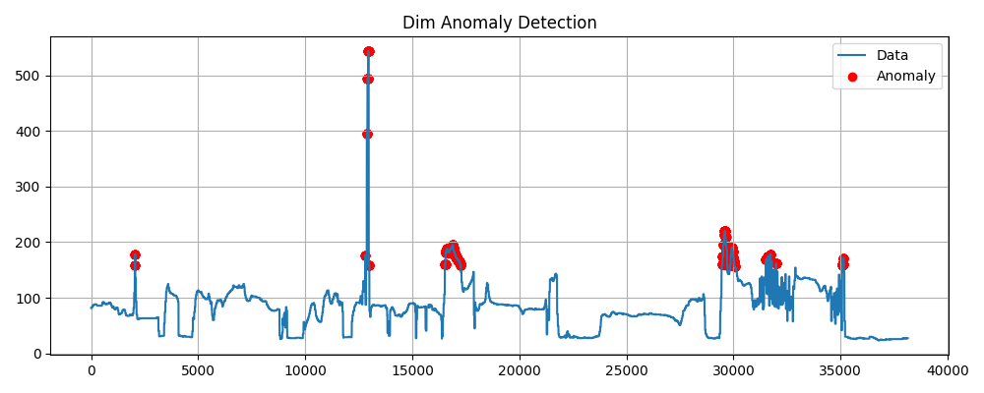

Dark Dataset
The dark dataset was analysed by plotting the raw sensor readings, applying a moving average filter, studying the data distribution using a histogram, identifying outliers through a boxplot and highlighting anomalies.
Raw Data
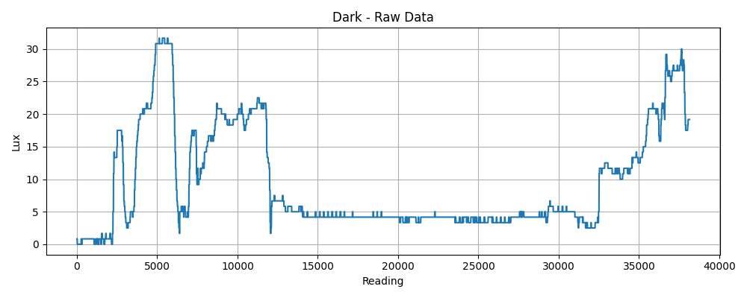
Smoothed Data
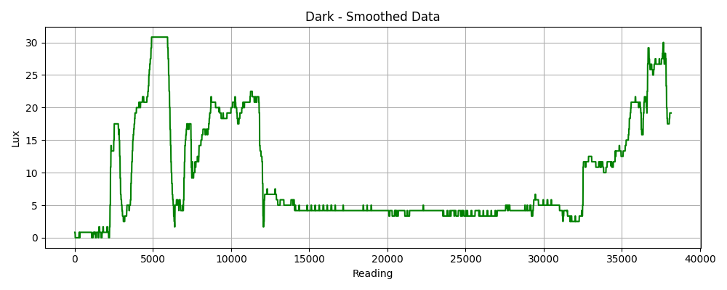

Histogram
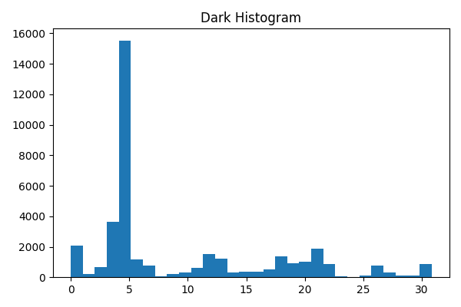
Boxplot
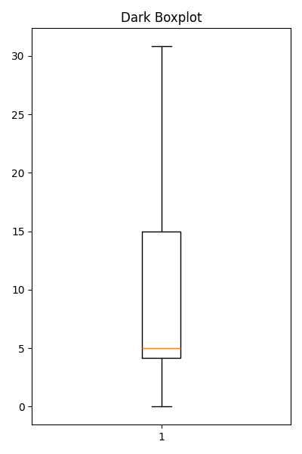

Anomaly Detection
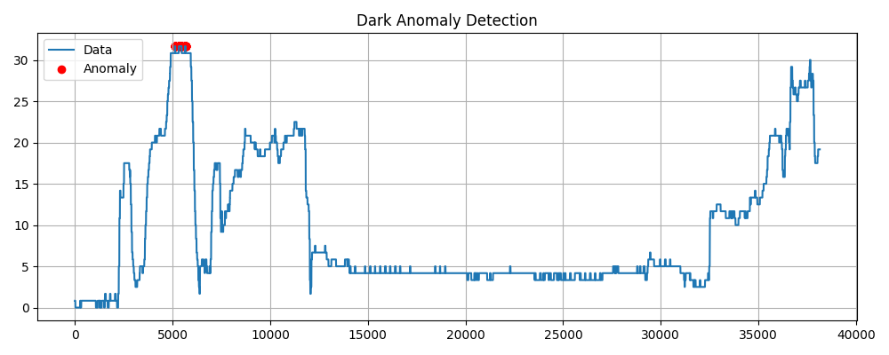

Observations:
- Bright dataset showed the highest lux values with a few large spikes identified as anomalies.
- Dim dataset remained relatively stable with moderate fluctuations.
- Dark dataset contained the lowest light intensity values and fewer extreme variations.
- The moving average filter reduced short-term noise and produced smoother trends.
- Histograms and boxplots helped understand the distribution and identify outliers.

Conclusion:
The Week 6 objectives were successfully completed. All three datasets were cleaned and analysed using Python. Statistical parameters, smoothing techniques and anomaly detection improved the understanding of the recorded light intensity data. The cleaned datasets are now suitable for further processing and machine learning tasks.

